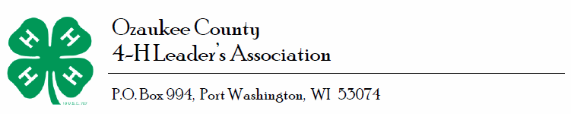

EXECUTIVE BOARD YOUTH LIAISON

CANDIDATE INFORMATION SHEET

Requirements: Must be enrolled in an Ozaukee County 4-H Club.
Date:_________________
Name:______________________________________________________
Club:_______________________________
Years involved with Club:__________ Years involved as a Leader:________

Leadership Roles held in your Club (be specific):

County Activity Involvement:

State Activity Involvement:

I think I can help the Ozaukee County 4-H program by:

Additional information on other Organizations or Board positions involved with outside of the 4-H program:

Signed:_________________________________________________________________

Personal Information:
Candidate Name (Please print): ______________________________________________________

Address: _____________________________________________________________

City/State/ZipCode: ____________________________________________________

Phone Number(s): Home:_____________________________
Cell:_________________________
Work: ______________________
Email: _______________________________________________________________

Return for to the UW Extension Office, PO Box 994, Port Washington, WI 53074

